**Dear DeJean Families,**

It is hard to believe we are already in December! There are only two more weeks until the Holiday Break, but we have a ton of parent and community events planned. We hope you will join us!

**December 5: 6:00–7:30 pm: African American Parent Advisory Council Meeting**

* We are looking forward to meeting with our African-American families, sharing our ideas, and learning more about the Hidden Genius project. The mission of this organization is to train and mentor Black male youth in technology creation, entrepreneurship, and leadership skills to transform their lives and communities. Check out this short [video](https://vimeo.com/292380575)!

**December 7: 6:00 - 7:00 pm: English Learner Advisory Committee (on Zoom).**

* During our first ELAC meeting, we will introduce our ELAC council members and review the ELD program offered at DeJean. Ms. Ferry will also be sharing literacy resources and holding space for parent input.

**December 8: 9:00 - 10:00 am: Coffee Chat with the Principal.**

* Our coffee chats are informal events where parents are welcome to drop in, grab a pastry and a cup of coffee, and sit down for a conversation with the principal. We are always looking for feedback on how we can better serve our students and support our families. Spanish translation is available.

**December 12: 2:30 - 7:30 pm: Affordable Connectivity Program (ACP) Enrollment Event.**

* At this event, our goal is to connect families with affordable internet service. Through the ACP, you could save $30 every month on your internet bill. Additionally, we will be raffling off a free laptop every half hour to those who attend this event!

**December 14: 6:00 - 7:00 pm: Winter Band Concert**

* Our local elementary students, DeJean students, and Kennedy band students will be coming together at the DeJean multipurpose room for the winter music showcase. Come listen to a beautiful music ensemble and wrap up the evening with a sweet treat!

**December 15: 12:00 - 1:25 pm: KWANZAA Assembly**

* On the last day of school before break, AAPAC and BSU are hosting a KWANZAA assembly for all our students. Also, remember this is a minimum day and students will be dismissed at 1:25 pm.

Please note that we are already in the middle of Q2. **Progress reports** have been sent out and include bills for any outstanding books or tablet charges your child may have. The end of the quarter won’t be until January 12th, so there is still plenty of time for students to raise their grades. Tutoring is available after school. Please call the office for more information.

**May the holidays bring your family peace, love, and joy this season.**

In Solidarity,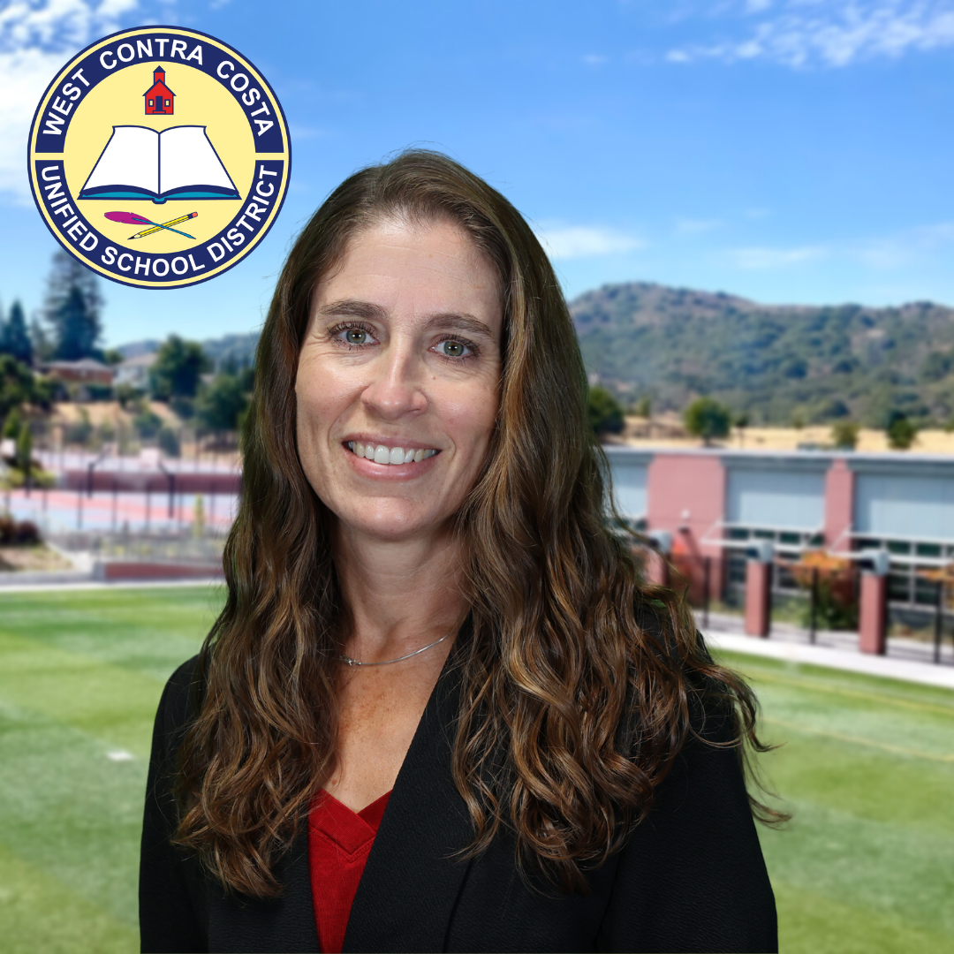

Athena Valdez

Principal